Art Education Six-Point Lesson Plan Template Lesson: _R for Ringgold___

Author: Taylor Gartman Grade Level: 7th Grade Middle School ( Lesson plan may be modified for elementary to high school students, but for today we are staying with middle school) ____
Period of time to complete Project: 1 ½ Week
Lesson Title: R for Ringgold

NC Essential Standards:
8.V.1.2 Apply the Elements of Art and Principles of Design in the planning and creation of personal art.
8.V.2.2 Apply observation skills and personal experiences to create original art.
8.CX.1.1 Understand the role of visual arts in North Carolina and the United States in relation to history and geography.
8.CX.2.1 Compare personal interests and abilities to those needed to succeed in a variety of art careers.

Activity | Description of Activities and Setting | Time
1. Focus and Review | Students will understand the role of Visual arts in the community and how the creation of the artwork is a reflection of the artist’s personal experiences and ideas. | 4 min
2. Statement of Objective  for Learner | Students will learn about Faith Ringgold’s journey as an artist and the influence of her narrative quilts that reflect the world around us. | 1 min
3. Teacher Input | The class will begin by going through the PowerPoint addressing key concepts, history, social issues regarding civil rights, and much more. Allowing the students to have conversations about Ringgold’s work, how it makes them feel, the message that is being conveyed. After the informational portion of the PowerPoint is complete students will begin researching and planning the creation of their personal story quilts.  Key Concepts:  Harlem Renaissance: which was a cultural, social, and artistic explosion considered to be a rebirth of African American arts  Folk- Art: rooted in and reflective of the cultural life of a community  Narrative art: art that tells a story, either as a moment in an ongoing story or as a sequence of events unfolding over time | 20 min
4. Guided Practice | Students will have a 22 x 16 piece of multimedia paper as their base for the quilt ( higher grade levels may be challenged to paint on fabric but for middle school, we are keeping to paper and scrap fabric patches).  Instructions:  - Pick out the fabric scraps you wish to use on the border, map out a 2.5 in the border around the paper. The fabric will be placed in the border area.  - Plan out your design the following are required elements the overall finished product should include:  - Fabric assembly around the edges of the paper  - At least 2 passages of text that aid in the storyline  - A determined setting or background  - The main character  Students may use a Story Element chart to help organize their ideas.  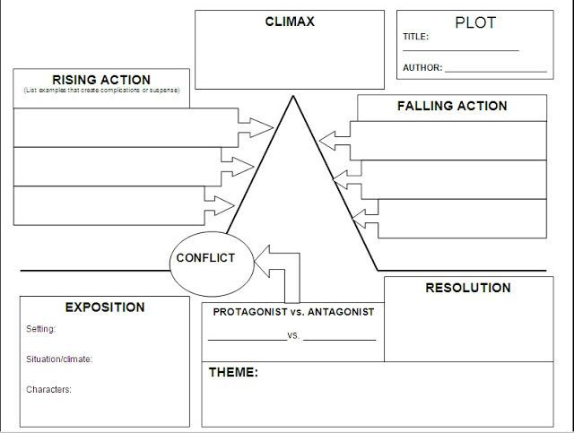
5. Independent Practice | Allow students to work and brainstorm some ideas. Consult with each student to see if they are confident on their project path. | 35 min
6. Closure and Clean Up: | Students will put up materials and place their sketchbooks and in-progress work in their designated areas. Before they leave have a quick review about what we went over today. | 5 min
Assessment Methods of  all objectives/skills: (Include any modifications) | -Multimedia artwork  -Narratives  -Incorporation of history.
Directed Questions for Discussion:
What’s going on in this image?
Why is she drawing light on this issue?
What elements spark discussion?
How do you create a narrative?

Modifications to Support Varied Learning Needs:
Fine Motor Skills: Fabric is cut up prior to the assignment so scissors are not in use.
Materials/Technology/References:
22x16 Paper
scissors
fabric scraps
paints
markers
pencils
pens
Story Plot graph print out

Reflection on the lesson:

